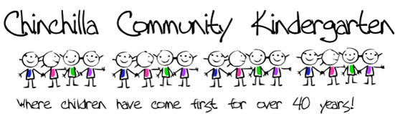
Chinchilla Community Kindergarten
24-26 Colamba St, P.O. Box 367 Chinchilla QLD 4413
Phone: (07) 4662 7028
Email: chinchillakindy@bigpond.com
Date:____________
Name of Parents/ Guardians: ______________________________________________
Postal Address: ______________________________________________
Home Phone Number: ______________________________________________
Mobile Number: ______________________________________________
Email address: ______________________________________________
I hereby apply for the Annual Membership of the Chinchilla Community Kindergarten Inc. for the year _________.
I accept the terms and conditions of membership under the constitution of the Chinchilla Community Kindergarten Inc. and understand that I may resign from the association at any time by giving notice in writing to the Secretary. I have full voting rights at any General Meeting.
Applicant’s Signature_____________________________
Child’s Details
Full Name:_____________________________________________________________
Date Of Birth:_______/_______/ 20_____
Preferred Session: Please circle below to indicate your preferred session. All Sessions run from 8:30am to 2:30pm
Session 1: Monday, Tuesday (alternate Wednesday) (5 day fortnight)
Session 2: Alternate Wednesday, Thursday and Friday (5 day fortnight)
Are you aware of any additional support that your child may require during his/her enrolment at the centre?____________________________
If for any reason, your child may need special assistance, please notify the centre as soon as possible so that the centre can plan for facilities and apply for funding to best meet the needs of your child.
Chinchilla Community Kindergarten is a fully IMMUNISED centre. Our enrolment requires evidence from MyGov that your child’s immunisation status is up-to-date before they can enrol. Evidence of 4 year old immunisation will need to be updated on file.
Please tick the statement below to indicate your child’s immunisation status.
My child’s immunisation status is up to date

Direct Deposit Details for Enrolment of $50.00 are:
Account Information
Chinchilla Community Kindergarten Association Inc
BSB: 084602
Account Number: 508672975
Please remember to put your child’s name as a reference on the transaction.

